**Distance Learning Activity, TUESDAY, MARCH 17:**

**ACADEMIC 10** 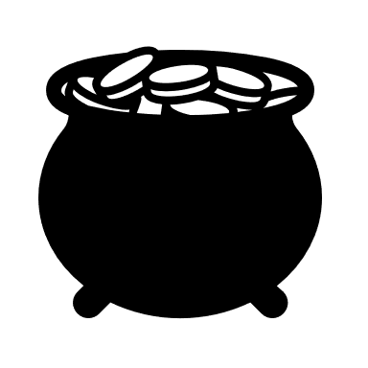

**Overview:**

* Today’s work involves self-reflection on independent reading, reviewing reading guidelines for the second half of your independent reading book, and starting your reading.

**Estimated Time:** Approximately 45 minutes

**Explanation/goals:**

* Reflect on your first half of independent reading
* preview what to do for the next round/focus areas for reading
* read

**Materials:**

* “first half of book checkpoint” sheet (on SchoolWires and in Canvas, under the “independent reading” tab)
* Reading tasks/instructions for second half of independent reading book (on SchoolWires and Canvas, under the “independent reading” tab)
* Your independent reading book at home

**Things to know:**

1. Independent reading book provides continuity with work already begun.
2. Independent reading helps you to practice and develop your close reading skills.
3. Independent reading fosters consideration of the development of identity.

**Tasks:**

1. Upload your typed 4 post its/analysis independent reading book work in Canvas. I see that many of you have already done that. Thanks! If not, please do so ASAP so that I may offer formative feedback.
2. Download the “first half of book checkpoint” sheet (either from SchoolWires or Canvas under the independent reading tab).
3. Using your notes from the first half of the book, complete the checkpoint sheet and upload it to Canvas.
4. Preview the reading tasks for the second half of the book (from SchoolWires or Canvas, under the “independent reading” tab). Be sure to find your column depending on the type of book you are reading (graphic novel, nonfiction, or fiction) for post it guidelines.
5. Spend the rest of your 45 minutes reading your independent reading book.

**Submission Guidelines:**

**How is this assignment turned in to the teacher and what kind of feedback will be received?**

* 4 post its/analysis work—upload in Canvas. Teacher will provide formative feedback there and notify you in lesson plans once complete.
* First half independent reading checkpoint—upload in Canvas. Teacher will review your work there and notify students of any concerns, if they arise.